

Meetings and More
56, Institutional Area , Sector 44,Gurugram.Haryana
1
FORM
Gurugram - 122003
P: 91 – 7022542056
Email: wcn25@meetingsnmore.com

ADDITIONAL FURNITURE REQUIREMENTS

PLEASE TYPE/ WRITE IN BLOCK LETTERS

Company Name: |  |  | Booth No:
Address:
Tel: | Fax: |  | Email:
Authorized by (Signature): |  |  | Date:

Please use this Form to order your furnishing needs. The STANDARD SHELL SCHEME package stand includes one Information Counter (T6), Two Chairs (C3) and one Waste Paper Basket. ORDER ONLY YOUR ADDITIONALREQUIREMENTS:
Code No. | PARTICULARS | Price in  (US $) | QTY | Total Amount
A1 | Standard Chair (Black) | USD 25 / INR 2075
A2 | Capsule Chair (White) | USD 30 / INR 2490
A3 | Standard Chair (White) | USD 25 / INR 2075
A4 | Bar Stool | USD 35 / INR 2905
A5 | Leather Bar Stool | USD 35 / INR 2905
A6 | Steel Brochure Stand | USD 28 / INR 2324
A7 | Single Seater Sofa | USD 40 / INR 3320
A8 | Double Seater Sofa | USD 65 / INR 5395
A9 | Triple Seater Sofa | USD 75 INR 6225
A10 | Glass Round Table | USD 35 INR 2905
A11 | Standard Octonorm Counter | USD 35 / INR 2905
A12 | Octonorm Lockable Table | USD 40 / INR 3320
A13 | Glass Showcase | USD 75 / INR 6225
A14 | Standing Glass Showcase | USD 100/INR 8300
A15 | Tower Glass Showcase | USD 85 / INR 7055
A16 | Only Flex print | USD 6 / INR 498 PER MTR
A17 | Flex Print Mount on Iron Frame | USD 9 / INR 747 PER MTR
A18 | Flex Print Mount on Wooden Frame | USD 10 / INR 830 PER MTR
A19 | Customized Fascia | USD 30 / INR 2490 PER MTR
A20 | Printed Carpet | USD 6 / INR 498 PER MTR
A21 | Flower Decoration | USD 28 / INR 2324 PER MTR
A22 | Flower Pot | USD 5 / INR 415 PER MTR
A23 | Fish Bowl | USD 5 / INR 415 PER MTR
 | NET TOTAL (USD/INR)
 | GST 18%
 | GRAND TOTAL (USD/INR)

REFERENCE PICTURES OF FURNITURE
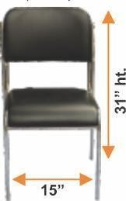 | 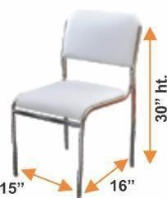 | 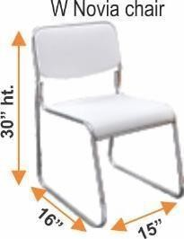 | 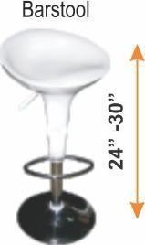
A1 Standard Chair (Black) | A2 Capsule Chair (Black/White) | A3 Standard Chair | A4 Bar Stool
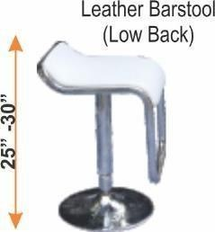 | 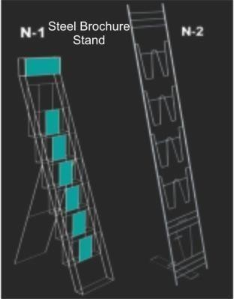 | 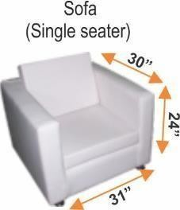 | 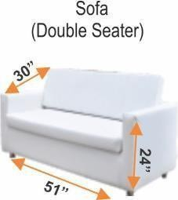
A5 Leather Bar Stool | A6 Steel Brochure Stand | A7 Single Seater Sofa | A8 Double Seater Sofa
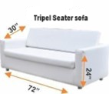 | 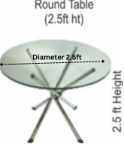 | 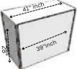 | 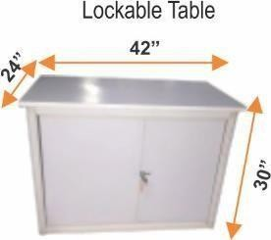
A9 Tripel Seater Sofa | A10 Glass Round Table | A11 Standard Octonorm Information Counter | A12 Octonorm Lockable Table
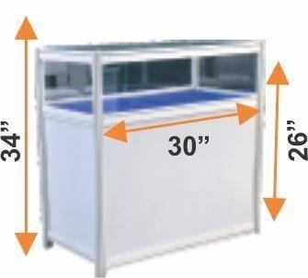 | 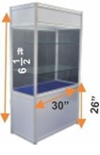 | 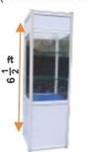
A13 Glass Showcase | A14 Standing Glass Showcase | A15 Tower Glass Showcase

BILLING INFORMATION

BILLING INFORMATION
Company’s registered name
Company’s GST number
Address
Zip code
Country
Po Number
Other remarks for invoicing and payments

Services will not be provided until payment has been received. Payment should be in favor of “INDIA FOR YOU HOLIDAYS PVT. LTD”
If the order is placed after 27.01.2025 then the exhibitor will pay an additional surcharge of 30%.
For USD Transfers:
Swift Code: HDFCINBBDEL
Name of Account: INDIA FOR YOU HOLIDAYS PVT. LTD.
Bank name: HDFC Bank Ltd.
Account No: 02802090000062
Branch: HDFC Bank Ltd, First India Place, M.G. Road, Gurgaon, Haryana

For Transfers within India
Name of Account: INDIA FOR YOU HOLIDAYS PVT. LTD.
Account No : 02802090000062
IFSC Code: HDFC0000280
Branch: HDFC Bank Ltd, First India Place, M.G. Road, Gurgaon, Haryana

*Please mail us a copy of your payment slip for confirmation.
- If payment is drawn in a foreign currency, please include any potential bank commissions in the transfer amount. If the final amount received is less than amount invoiced due to exchange rate variances or charges levied by the transferring bank, you will be responsible for clearing the balance amount ahead of receiving requested services.
,
- Late Orders received after the deadline – 27.01.2025 will be provided subject to availability, will be subject to a 30% surcharge and 50% surcharge for onsite orders. Priority will be given to advance orders.
- 30% cancellation fees will be imposed for cancellation of confirmed order. There will be no refund for cancellation during show days.
- All materials to be available subject to availability and first come first served basis.
- Applicable Government Service Taxes (GST @ 18%) are extra.

